ICP SUBMISSION 1

Below are the screenshots for the tools and applications installed:

GITHUB DESKTOP:

A screenshot of a computer screen

Description generated with very high confidence

GITSHELL:

A screen shot of a computer

Description generated with very high confidence

ZENHUB:

A screenshot of a computer

Description generated with very high confidence

CREATLY:

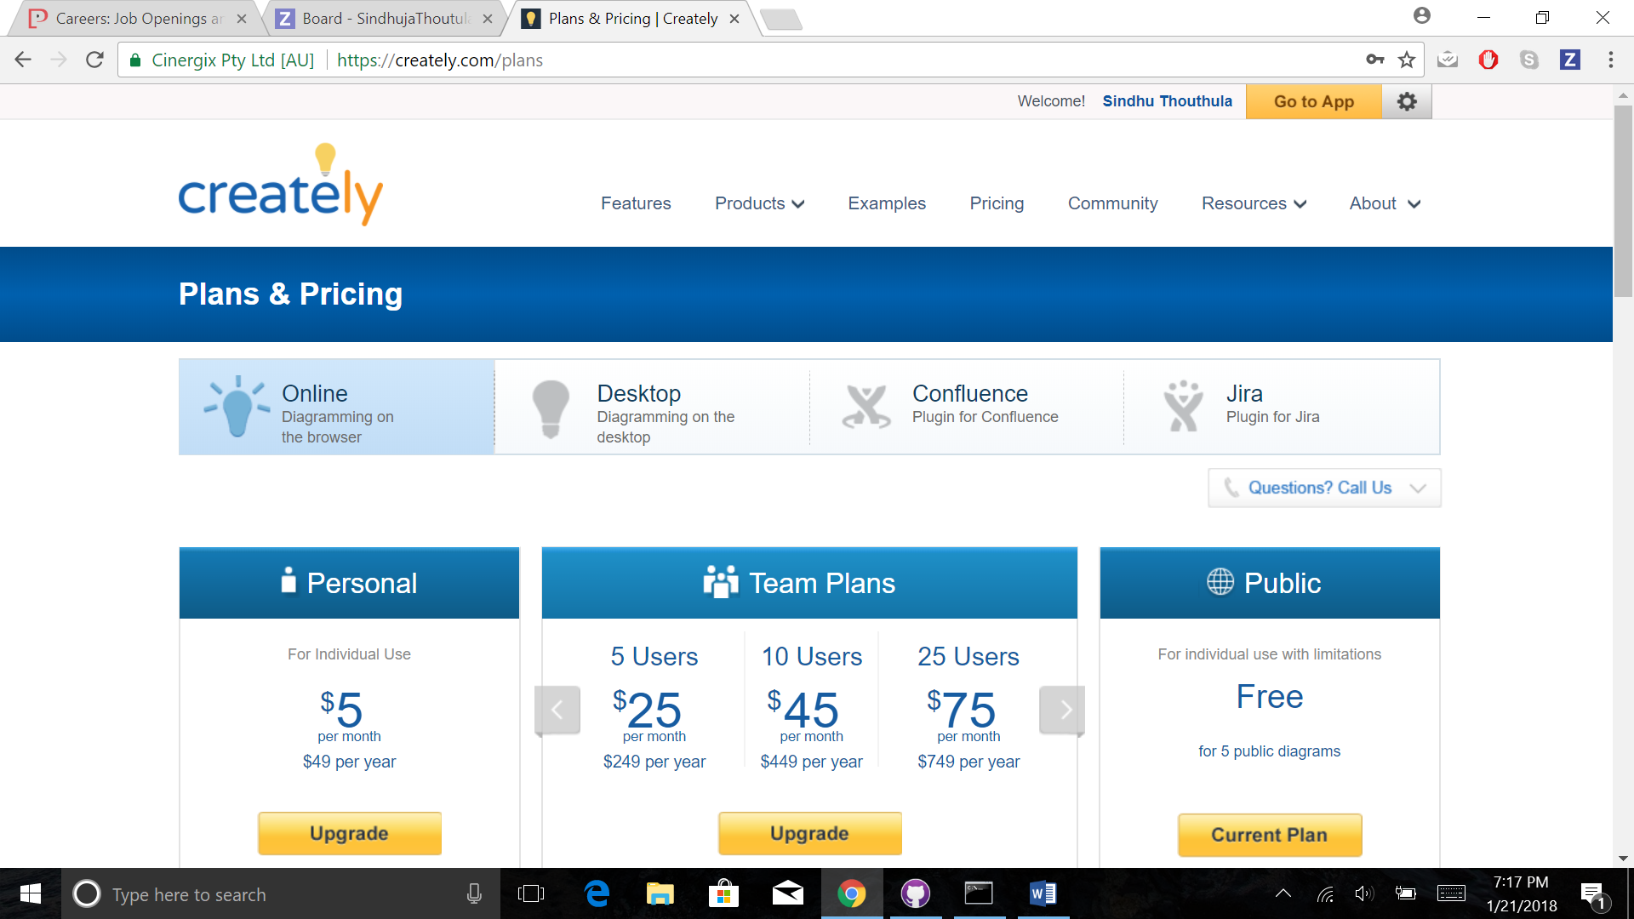

WEBSTROM:

A screenshot of a cell phone

Description generated with very high confidence

ANDROID STUDIO

A screenshot of a computer

Description generated with very high confidence

BRACKETS:

A screenshot of a cell phone

Description generated with very high confidence

NODEJS, NPM AND IONIC:

A screen shot of a computer

Description generated with very high confidence